**Network Cisco Switches & Routers:**

**“Lab Assignment”**

**Lab 2**

**CIS 202L**

**Rafat Khandaker**

**11/18/18**

**Assignment**

Using the **NETLAB+ virtual environment**, complete the following activities.

Click on the Show Lab Content button after you schedule the lab.

It is strongly suggested that you open the Lab Content in one window and the topology image in another and arrange them side by side so you may read the instructions in one window and enter the commands in the other.

**The physical cable connections have already been made in the NETLAB+ system. Any reference in the lab regarding connecting cables should be ignored.**

Interface names may vary among network device types. The interface names shown in the topology image are consistent with those found in the lab activity document. Use the IOS **show interface** and **show controllers** commands to determine the actual interface names for the devices used in the lab pod.

When you have completed the activities, answer the questions that are within the individual labs in a single Word Document. Save and name your file, "***CIS202L_U2_LabAssignment_LastName.docx"***. Submit your file using the below Upload Instructions.

You must complete the activities in the following order:

* **Lab 2.1: Building a Simple Switch and Router Network**
* [Building a Simple Switch and Router Network](https://ecpi.instructure.com/courses/34772/files/5113754/download?verifier=N96xmrhKgxwL4eS69xTyDaLSpEhDU1k1tbudSl7U)
* **Lab 2.2: Designing and Implementing a Subnetted Network**
* [Designing and Implementing a Subnetted Network](https://ecpi.instructure.com/courses/34772/files/5113794/download?verifier=9jgylvsfNOmoKrIq9piG8U8omQFBW5H2btGREeUn)
* **Lab 2.3: Using Router and Switch CLI to Map Network Machines**
* [Using Router and Switch CLI to Map Network Machines](https://ecpi.instructure.com/courses/34772/files/5113760/download?verifier=64KPqyoNJ6ihfNtjkc5i0F92BXIL6cVx69Zy7rwK)
* **Lab 2.4 Exploring Spanning Tree Protocol and Root Bridge Configuration**
* [Exploring Spanning Tree Protocol and Root Bridge Configuration](https://ecpi.instructure.com/courses/34772/files/5113762/download?verifier=ky5A2uqy4dShGgTop7rOpRnO3a3efPHAShrGfOhM)

**Lab 2.1 Building a Simple Switch and Router Network**

**Objective** – The student will be able design and configure the router, switch, and host PCs to have end

to end connectivity using a predesigned network scheme.

**Topology:**

Laptop0 is connected to a switch, which is connected to a router, which is connected to another Laptop.

It is preferred to do this on live routers or using the remote VCASTLE pod. Packet Tracer can be used for

preliminary configuration/testing.

**Instructions**:

**Part 1.** Using the topology map above, open up a new instance of Wireshark and build this

network as seen above, and using the same interfaces as depicted. Be careful to use the right

cabling.

**Part 2**. You should use th e Network Addressing table below to configure a small routed network. This

can be done in VCASTLE, or on live equipment. Note that Packet Tracer can be used to build an initial

network, but using live equipment is the way to really learn how live equipment behaves.

Router0 G0/0 192.168.2.1 255.255.255.224 N/A

Router0 G0/1 192.168.2.33 255.255.255.224 N/A

Router0 Loop0 192.168.3.1 255.255.255.255 N/A

Router0 Loop1 192.168.4.1 255.255.255.255 N/A

Switch0 VLAN 1 192.168.2.2 255.255.255.224 192.168.2.1

Laptop0 NIC –FaEth0 192.168.2.30 255.255.255.224 192.168.2.1

Laptop1 NIC- FaEth0 192.168.2.62 255.255.255.224 192.168.2.33

Note: Be careful not to let the respective host range of the subnets overlap each other.

1) What are the four network numbers?

a. **192.168.2.0 /27**

b. **192.168.2.32 /27**

c. **192.168.3.0 /32**

d. **192.168.4.1 /32**

**Part 2. Configure the network devices with the addresses in your table.**

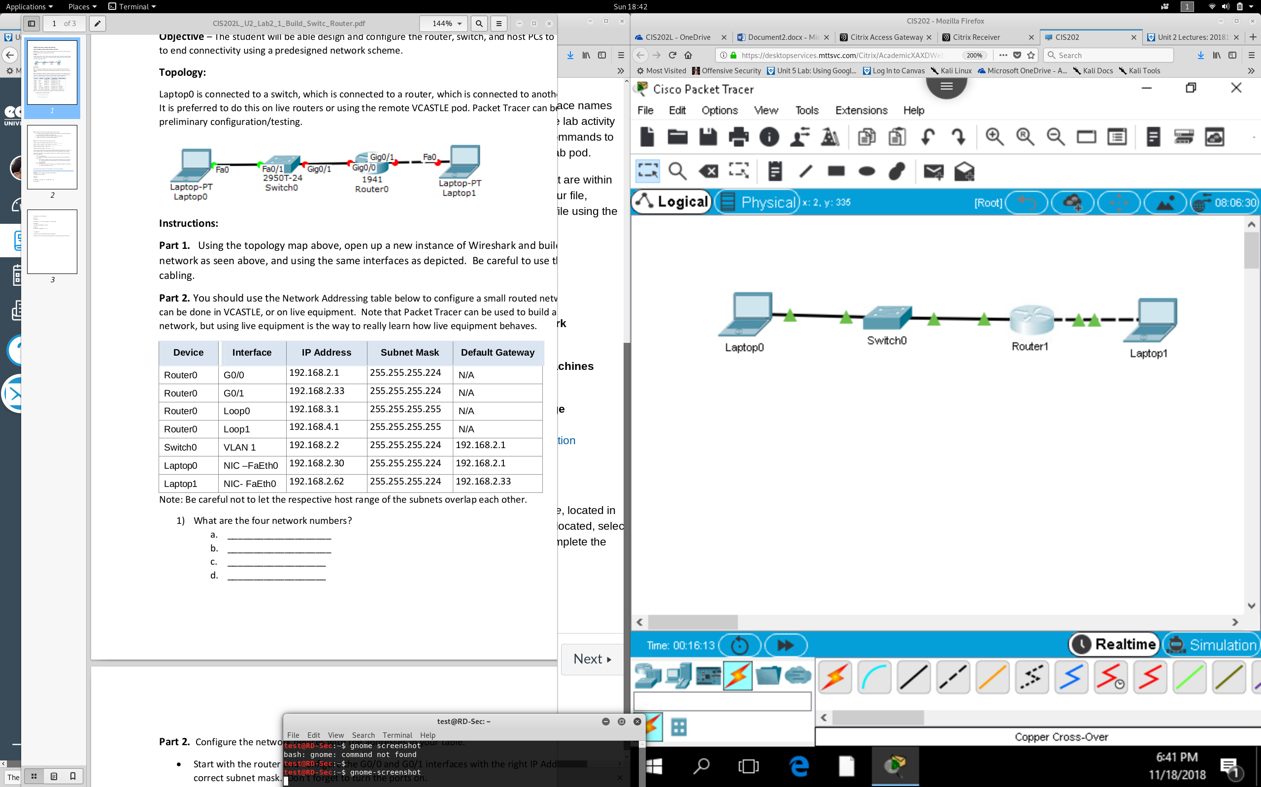

Start with the router and configure the G0/0 and G0/1 interfaces with the right IP Addresses and

correct subnet mask. Don’t forget to turn the ports on.

Configure the laptop hosts with their IP Addresses and default gateways.

Configure the switch with its address and default gateway.

**Part 3 . Test the network to confirm end to end connectivity**

Ping from Laptop 0 to the Router’s G0/0 IP Address. Did it work? **YES !**

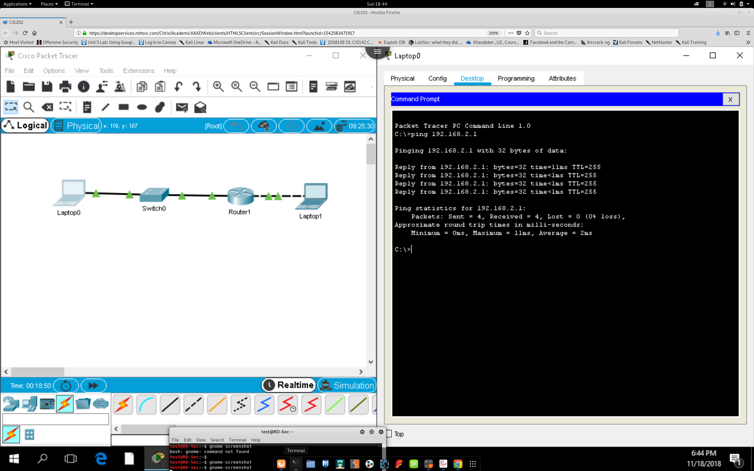

Ping from Laptop1 to the Router’s G0/1 IP Address. Did it work? **YES !**

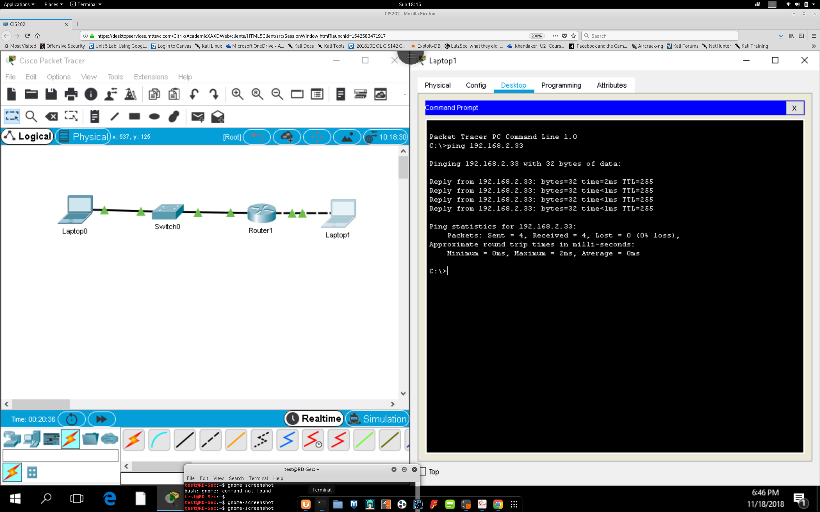

Ping from Laptop 0 to Laptop 1. Did it work? **YES !**

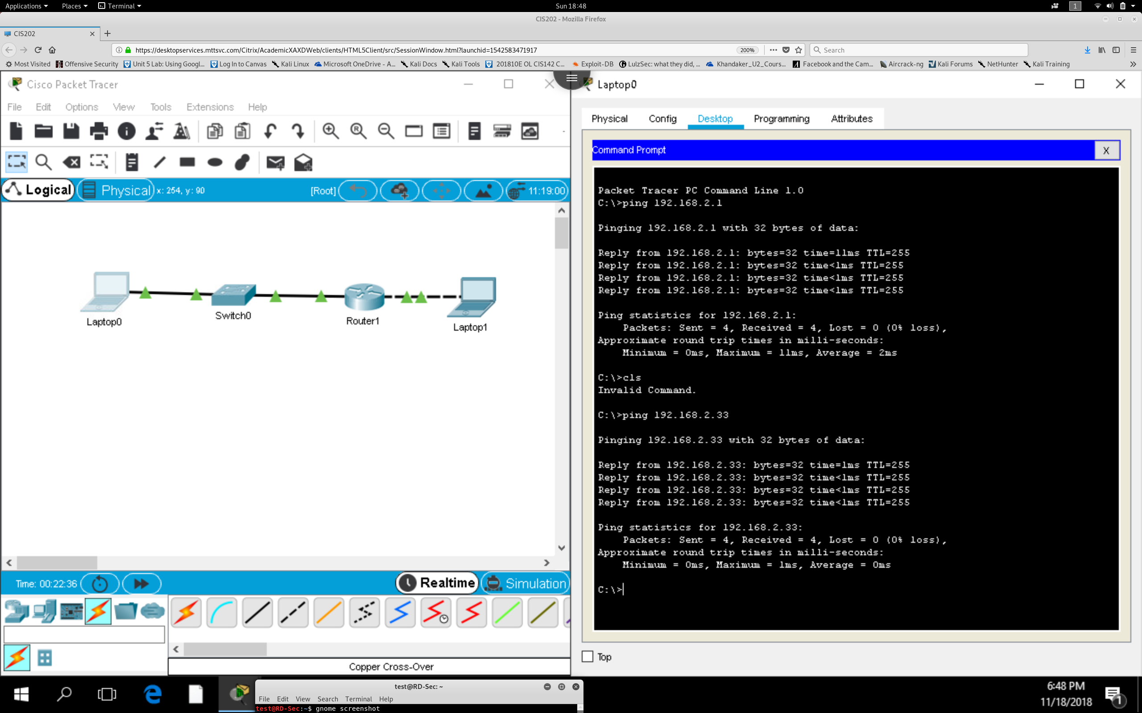

Ping from the Switch to Laptop 1. Did it work? **YES !**

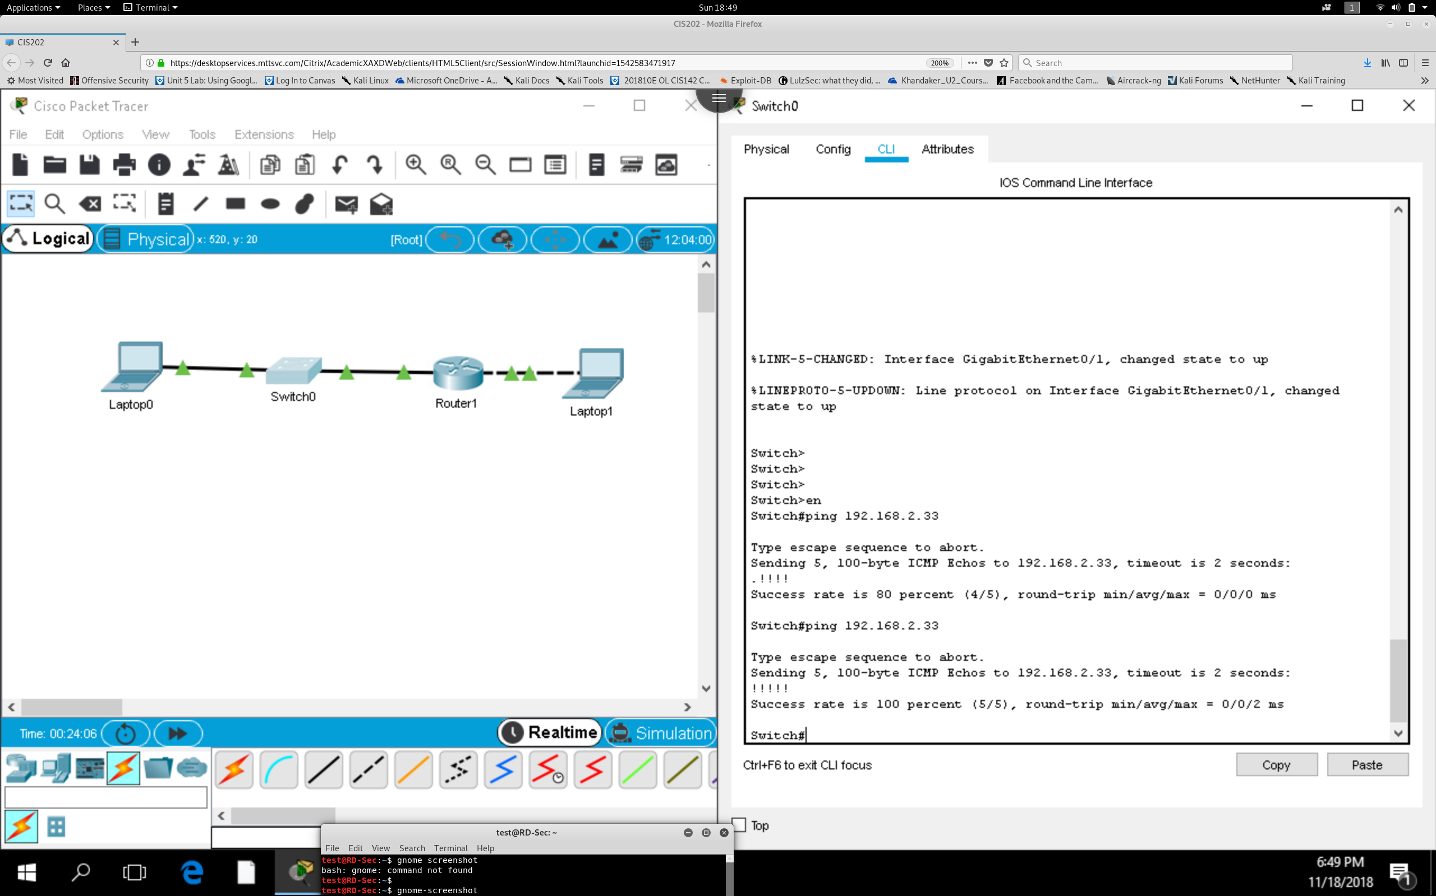

**ALL IS CONFIGURED CORRECTLY !**

**Lab 2.2 Designing and Implementing a Subnetted Network**

**Objective**: The student will be able configure the router, switch, and host PCs to have end-to-end

connectivity on a network that has been subnetted using IPv4.

Topology:

Laptop0 is connected to a switch, which is connected to a router, which is connected to another Laptop.

It is preferred to do this on live routers or using the remote VCASTLE pod. Packet Tracer can be used for

preliminary configuration/testing.

**Instructions**:

**Part 1:**

**Design the Network Addressing using a non-standard subnet mask and fill in the table below**

*it reflects your design. Requirements:*

* The Router’s G0/0 network will be based on 192.168.2.0/24 and require about 28 addresses.
* The Router’s G0/1 network will also be based on 192.168.2.0/24 and only require 6 addresses.
* The first usable address in each network host range is assigned to the default gateway for that
* network.
* The last usable address in each network host range can be assigned to the respective laptop PC.
* Configure the switch with an unused address from the correct network.
* The loopback addresses will represent networks of 2 hosts each.

|  |  |  |  |  |
| --- | --- | --- | --- | --- |
| **Device** | **Interface** | **IP Address** | **Subnet Mask** | **Default Gateway** |
| **Router0** | Gig 0/0 | 192.168.2.1 | 255.255.255.224 | N/A |
| **Router0** | Gig 0/1 | 192.168.2.33 | 255.255.255.248 | N/A |
| **Router0** | Lo0 | 192.168.3.1 | 255.255.255.255 | N/A |
| **Router0** | Lo1 | 192.168.4.1 | 255.255.255.255 | N/A |
| **Switch0** | VLAN 1 | 192.168.2.2 | 255.255.255.224 | 192.168.2.1 |
| **Laptop0** | NIC - FaEth0 | 192.168.2.30 | 255.255.255.224 | 192.168.2.1 |
| **Laptop1** | NIC - FaEth0 | 192.168.2.38 | 255.255.255.248 | 192.168.2.33 |

Switch0 VLAN 1 Laptop0 NIC –FaEth0 Laptop1 NIC- FaEth0

Note: Be careful not to let the respective host range of the subnets overlap each other.

1) What are the four network numbers?

a. **192.168.2.0 /27**

b. **192.168.2.32 /29**

c. **192.168.3.0 /32**

d. **192.168.4.0 /32**

**Part 2. Configure the network devices with the addresses in your table.**

* Start with the router and configure the G0/0 and G0/1 int with the right IP Addresses
* correct subnet mask. Don’t forget to turn the ports on.
* Configure the laptop hosts with their IP Addresses and default gateways.
* Configure the switch with its address and default gateway.

*Here is an MVP (Most Valuable Procedure): if you are doing this on live equipment, remember that*

*you can do this in Packet Tracer to test it....and when you have it working.....*

**1)** Issue show run

**2)** Highlight the configuration output.

**3)** Copy it.

**4)** Carefully paste it into a live router or switch

**Switch :**

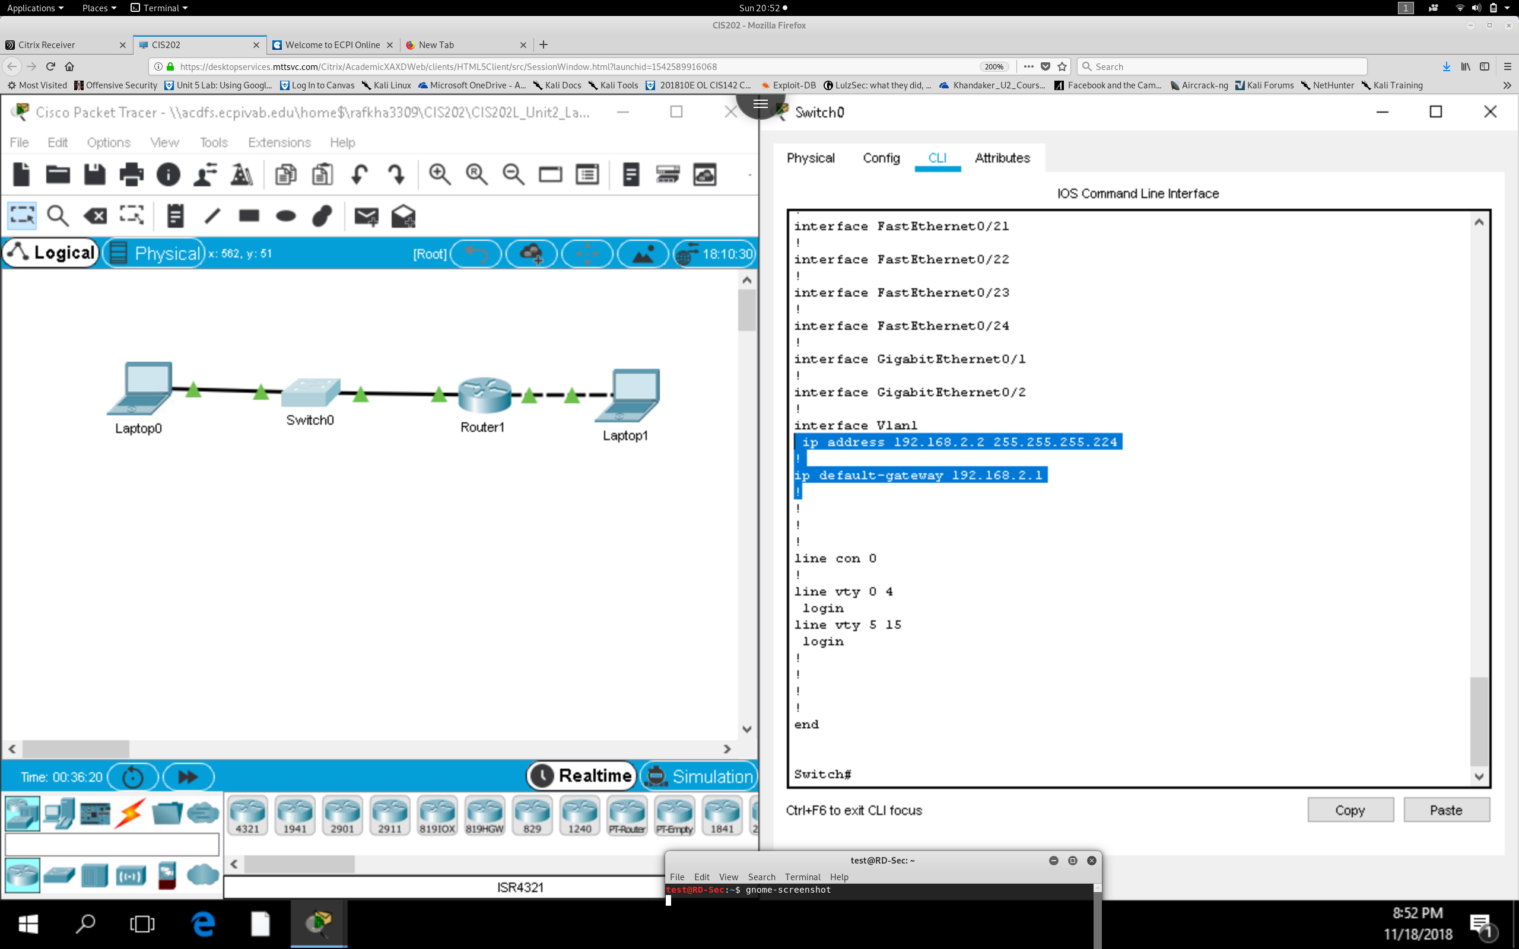

**Router :**

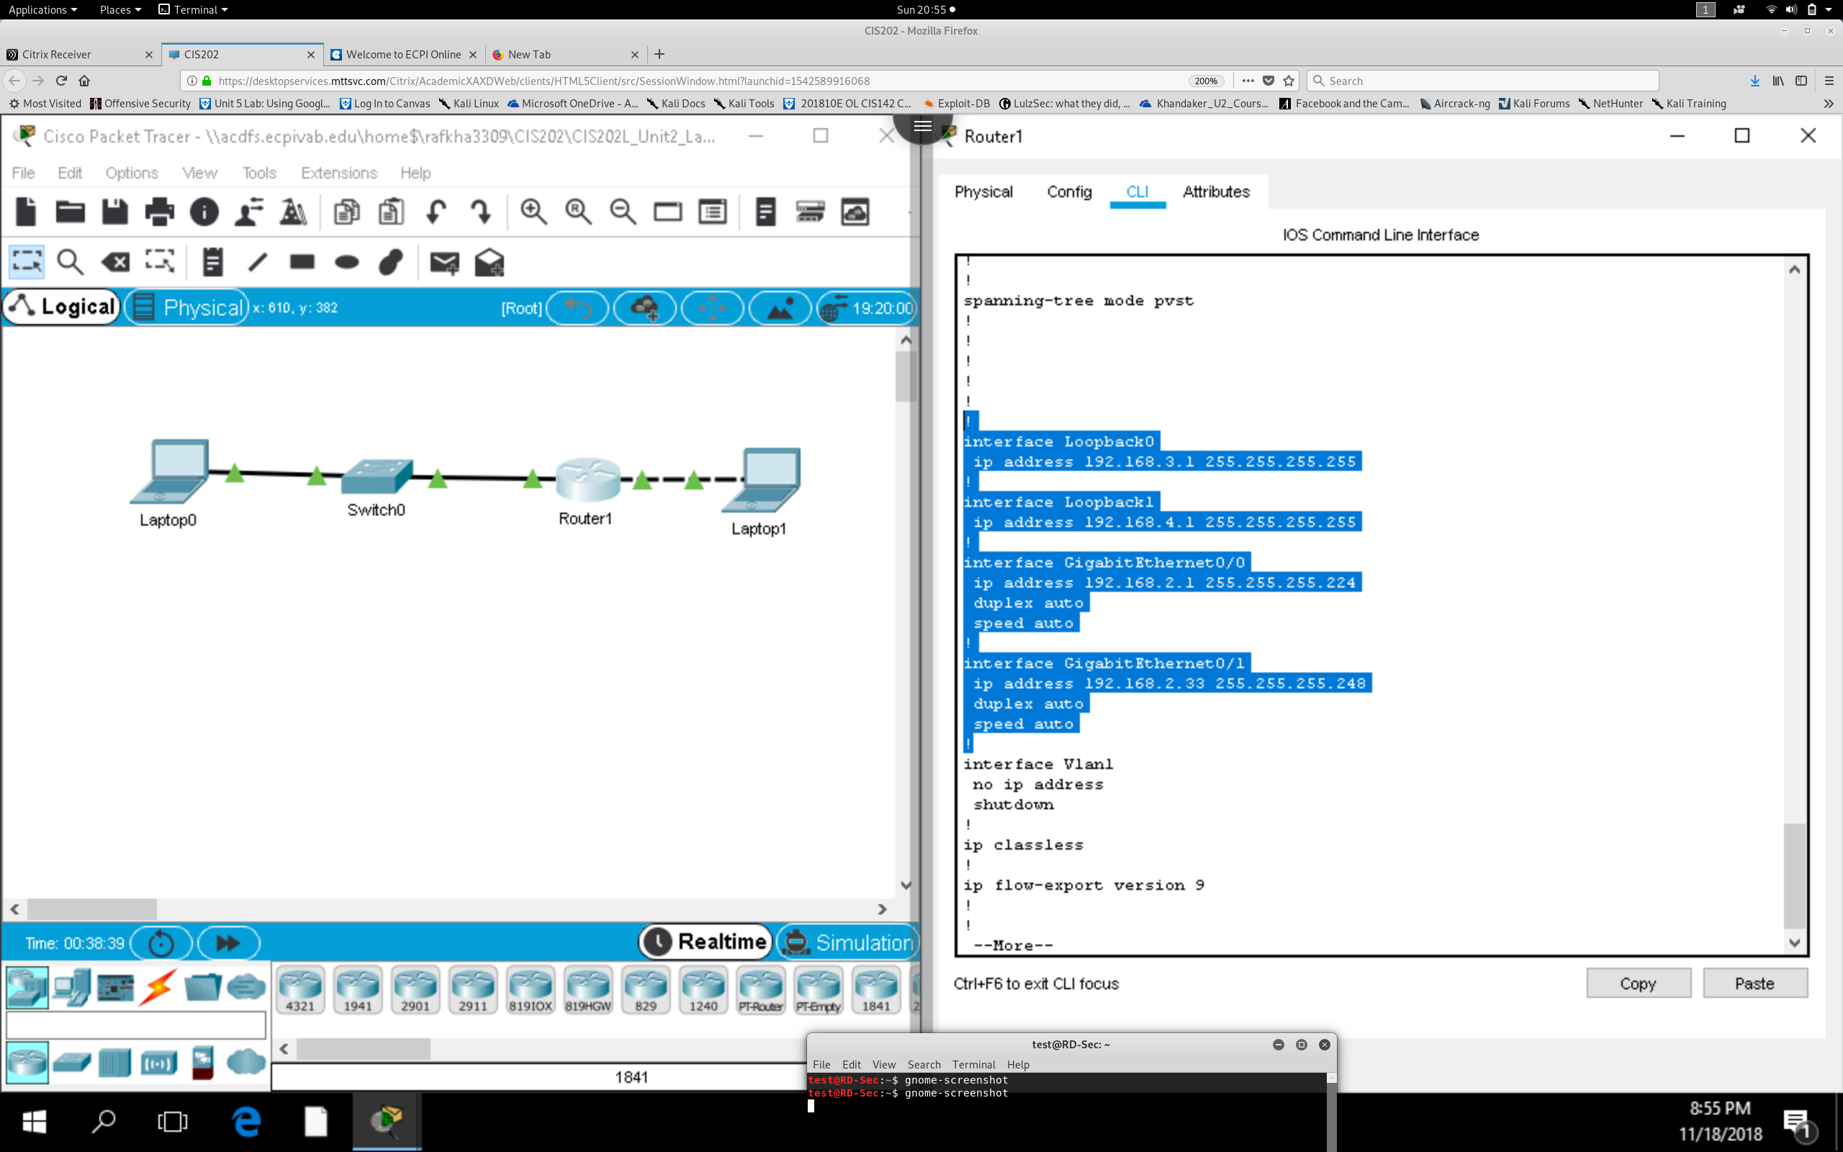

**Part 3 . Test the network to confirm end to end connectivity**

Ping from Laptop 0 to the Router’s G0/0 IP Address. Did it work? **YES !**

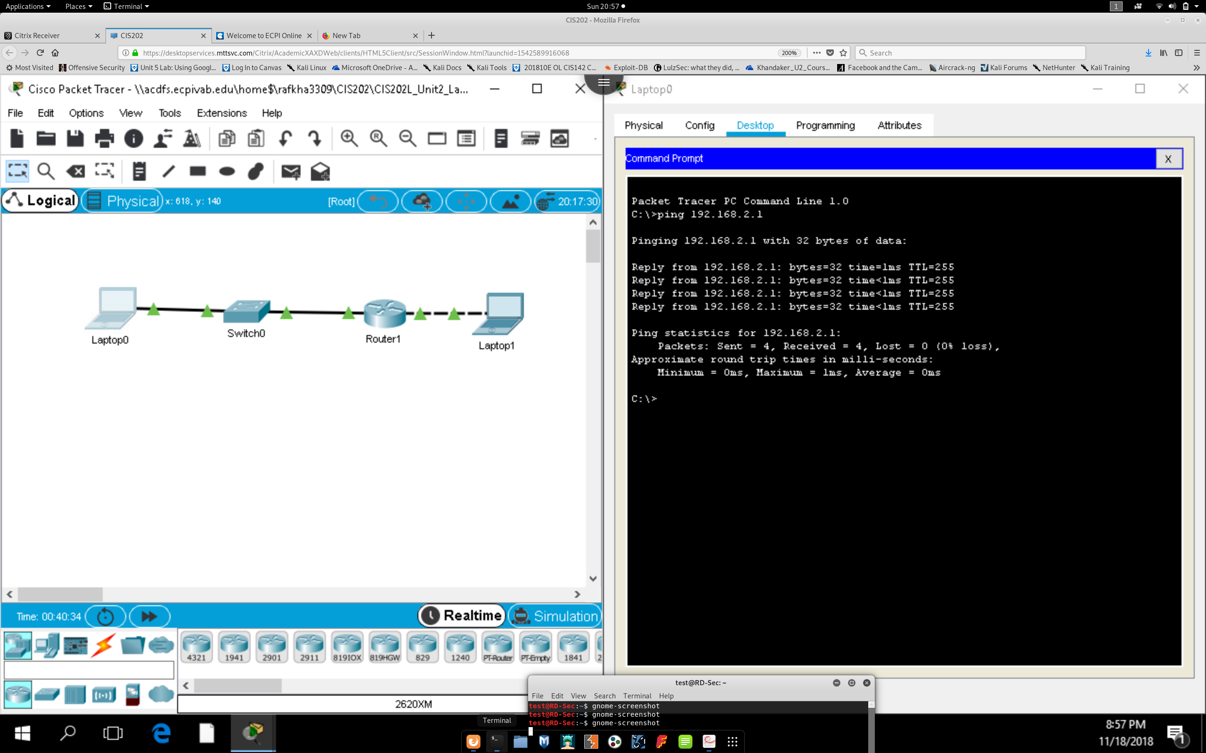

Ping from Laptop1 to the Router’s G0/1 IP Address. Did it work? **YES !**

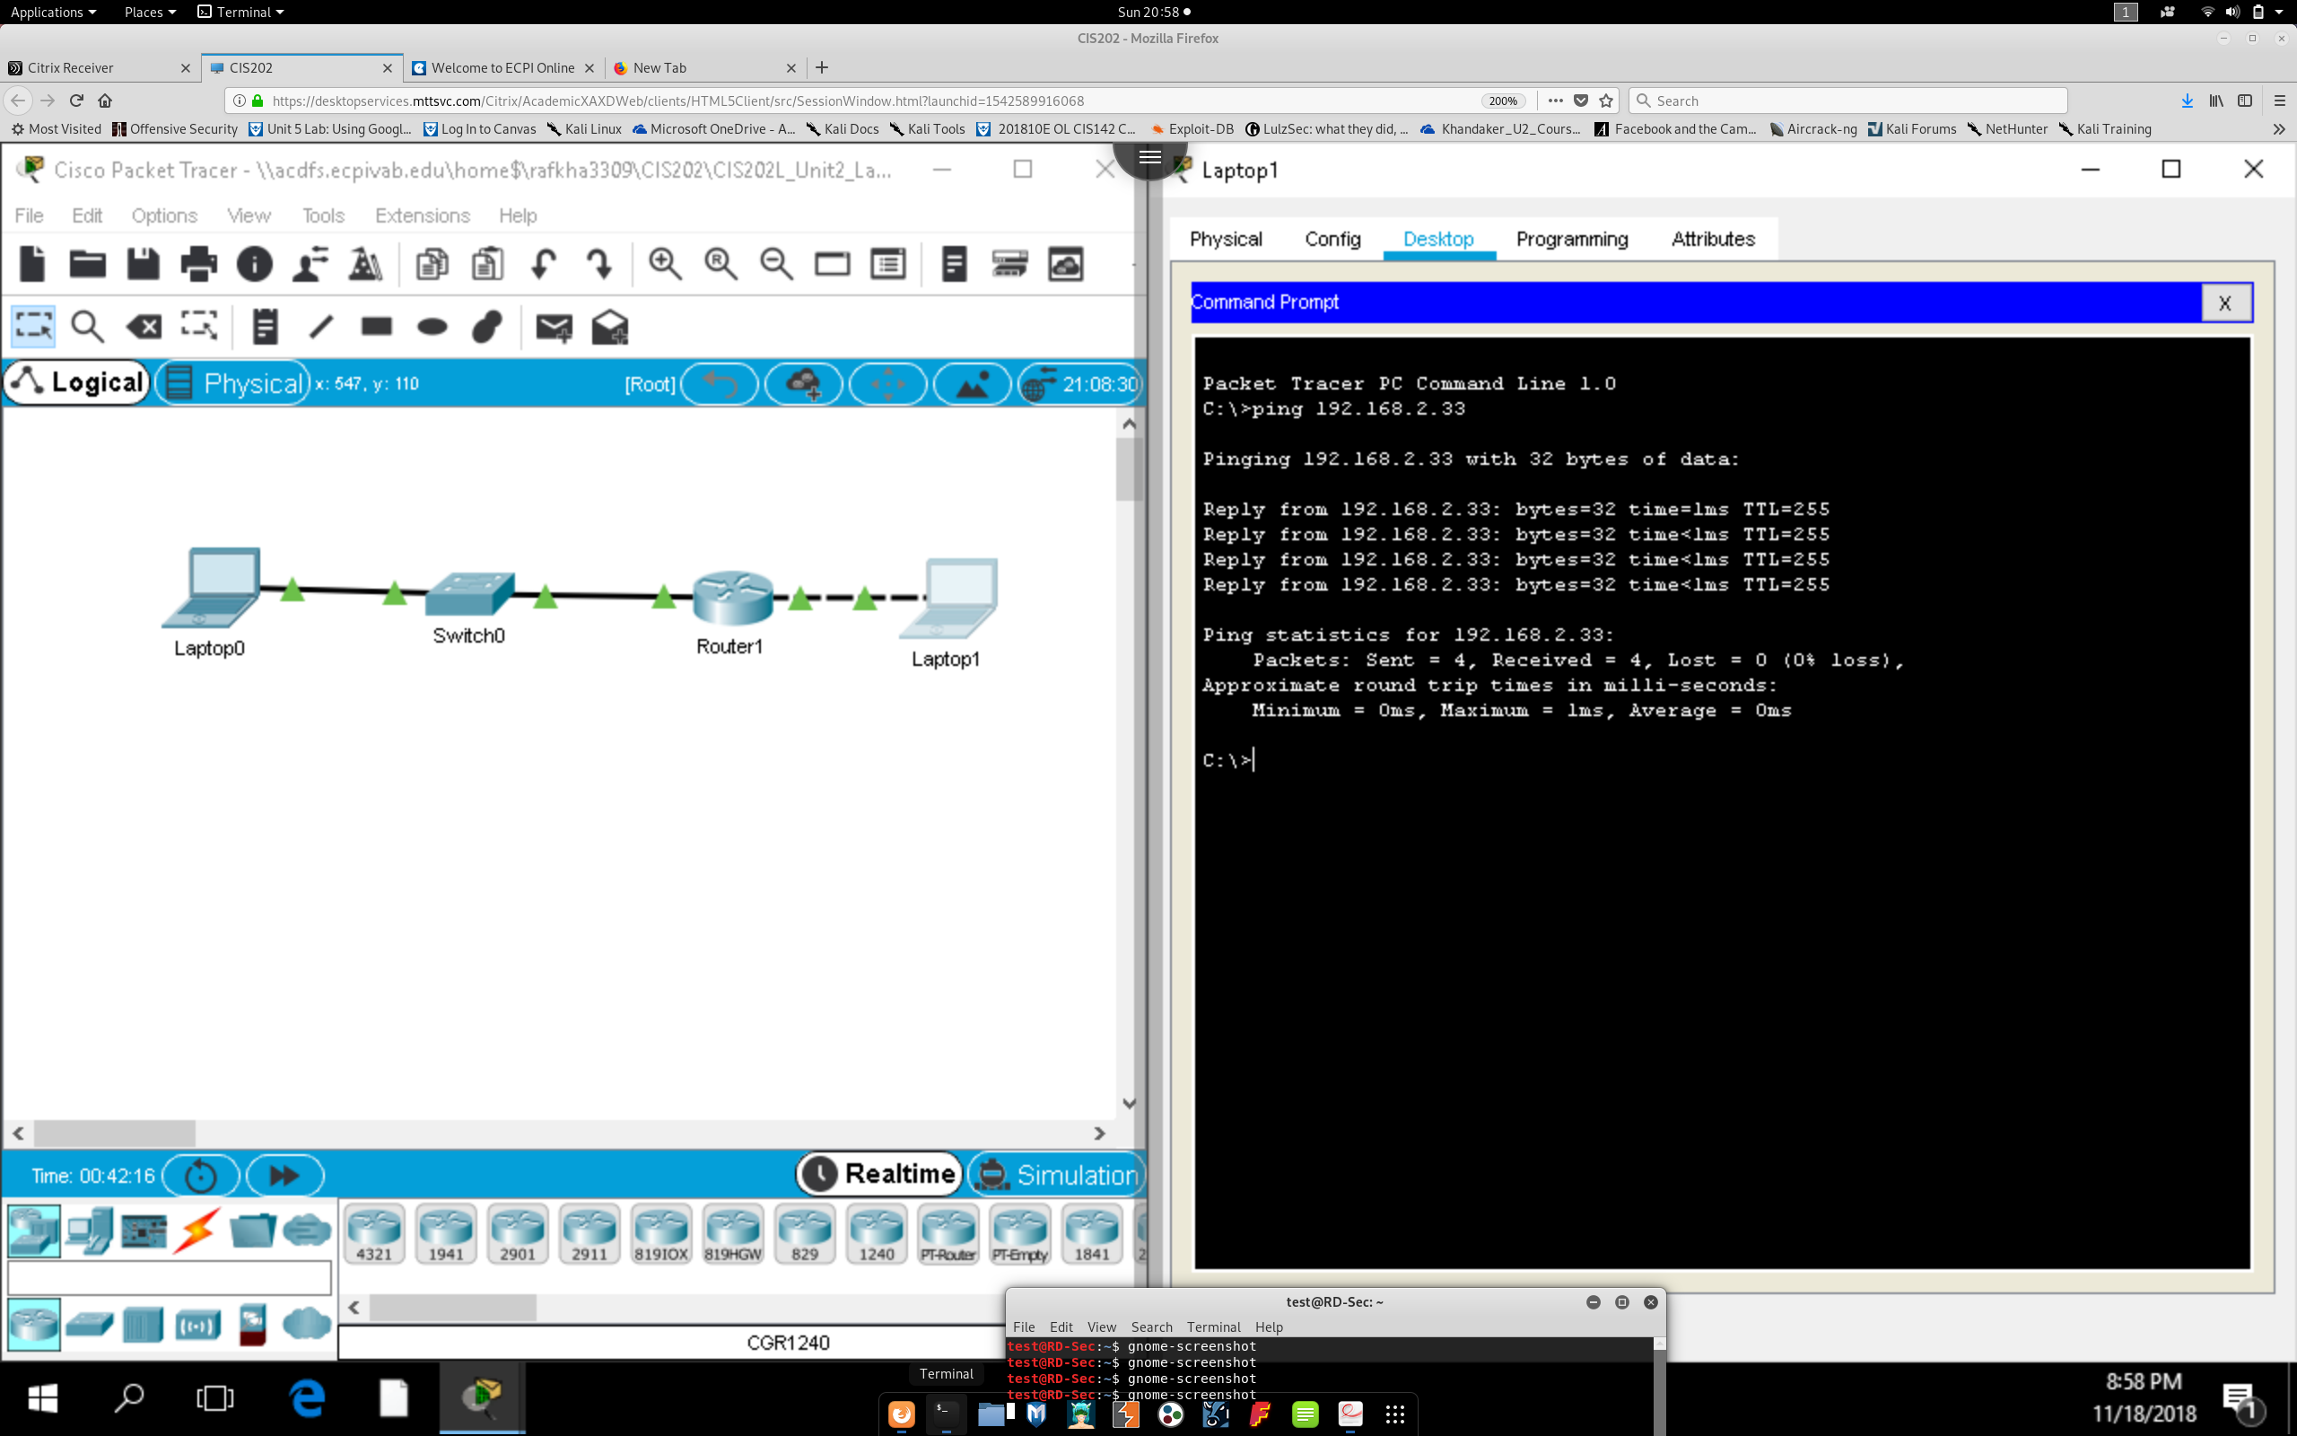

Ping from Laptop 0 to Laptop 1. Did it work? **YES !**

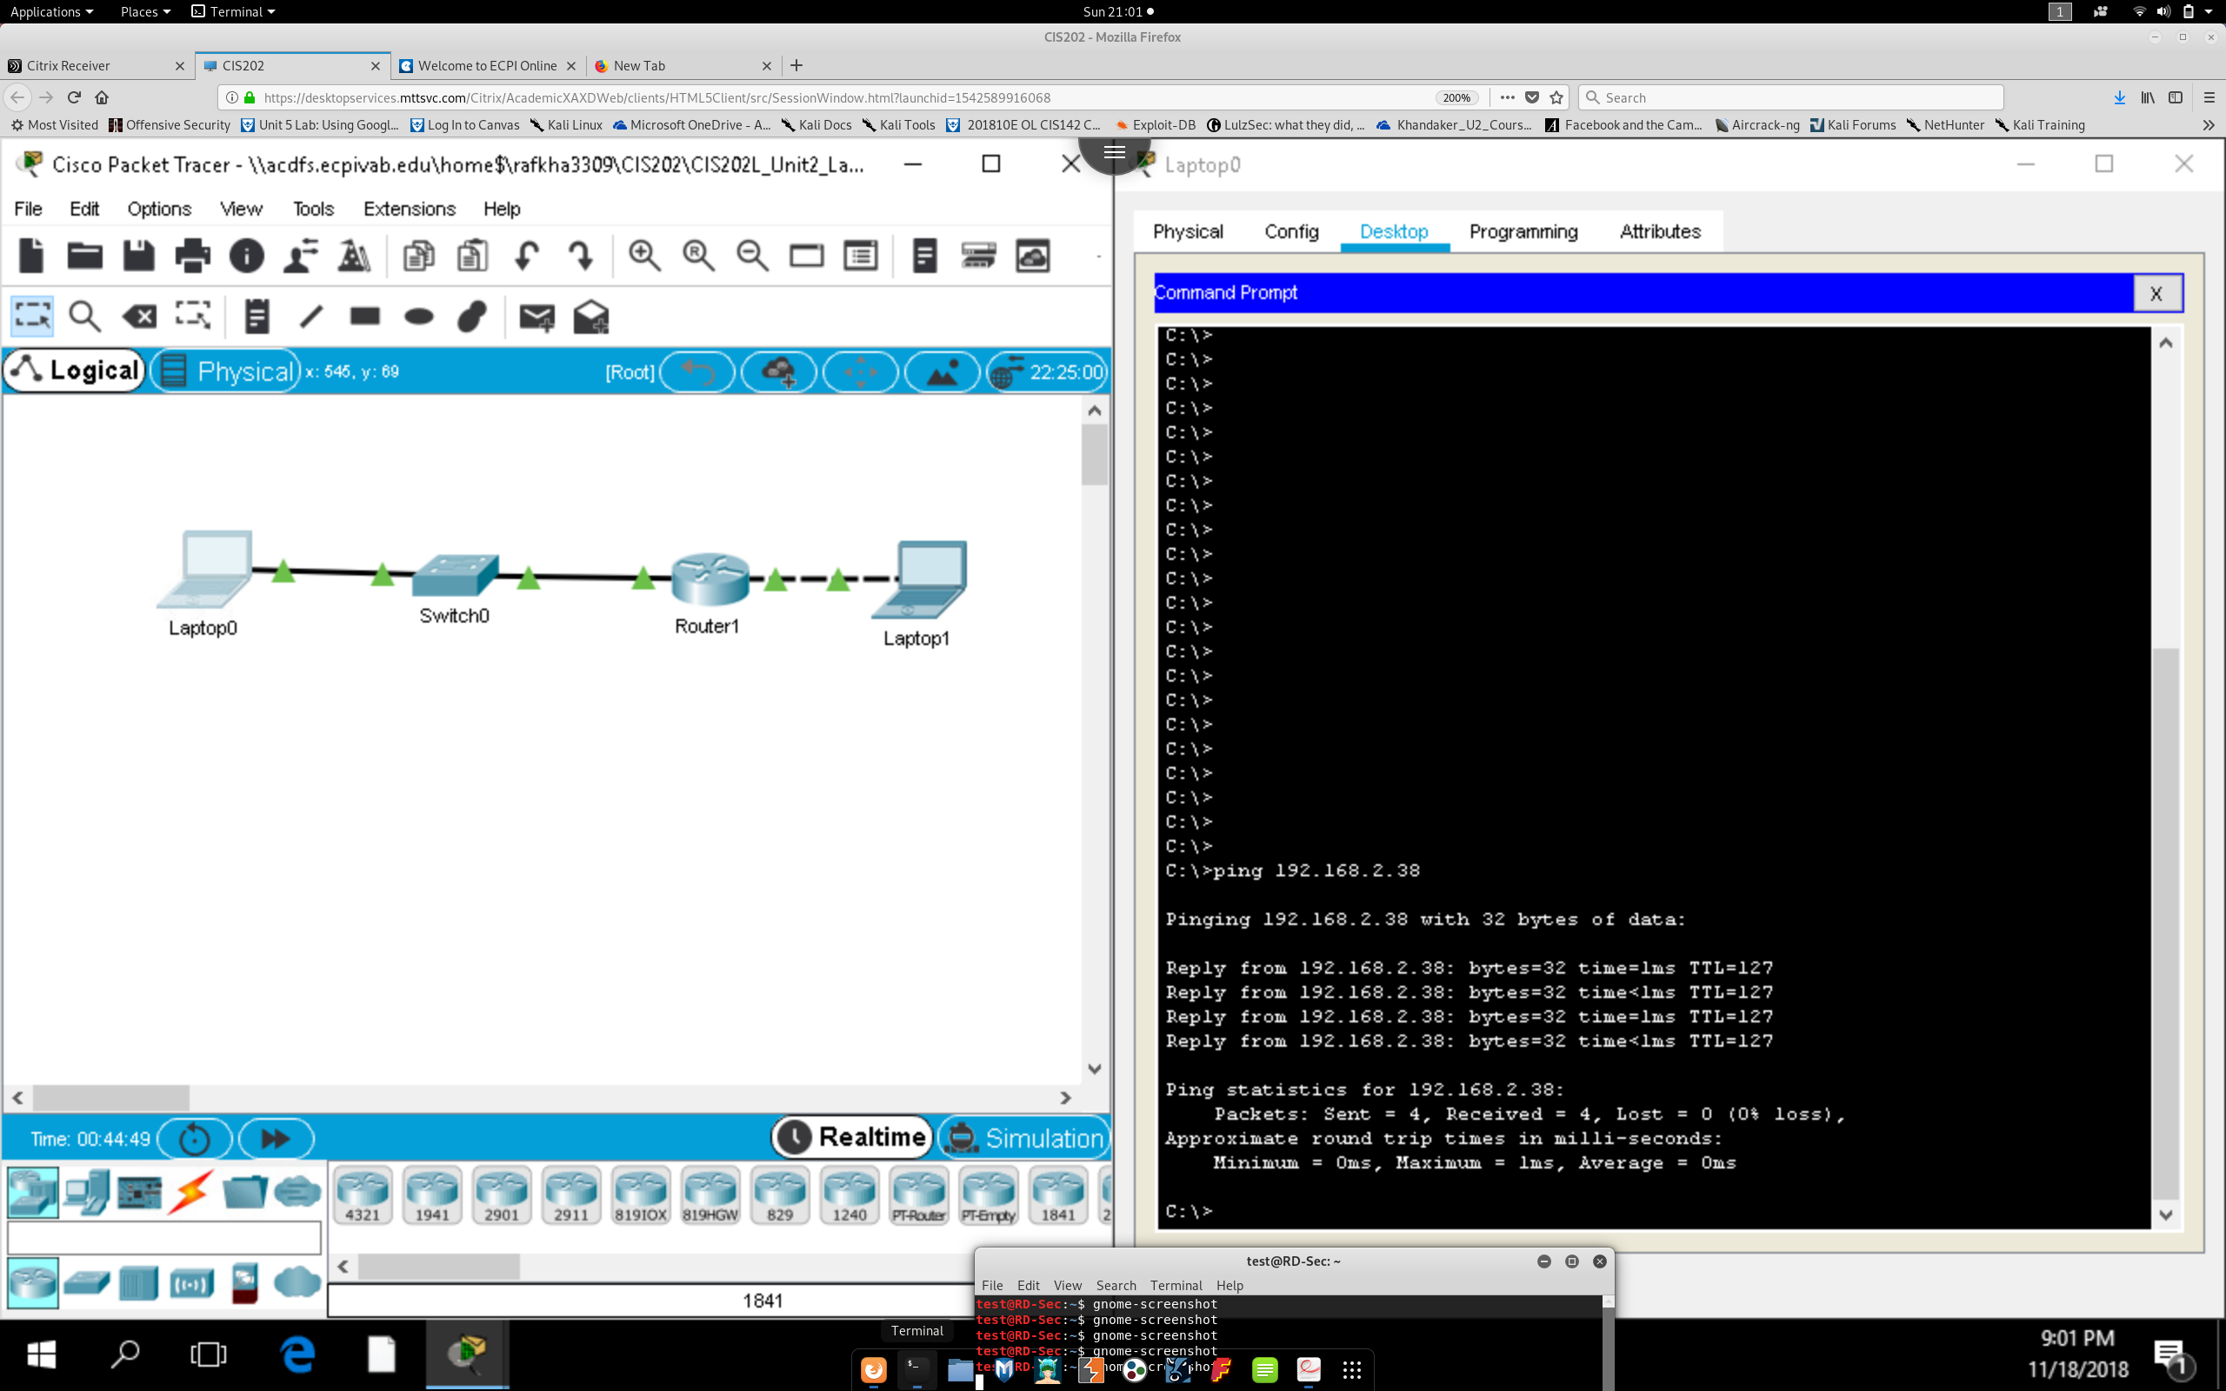

Ping from the Switch to Laptop 1. Did it work? **Yes !**

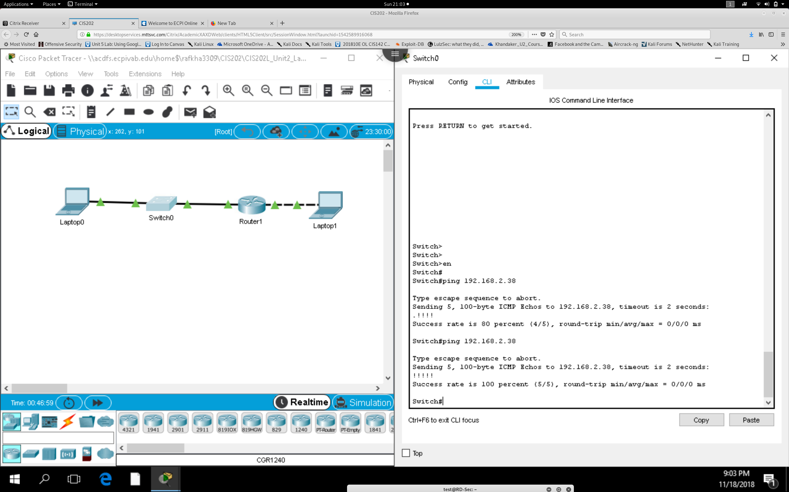

If any of these three pings failed to work properly, go back and troubleshoot the problem. Use your OSI

model understanding to start from the physical layer and work up to the application layer if needed.

**EVERYTHING WORKS !**

**Lab 2.3 Using Router and Switch CLI to Map Network Machines**

***Objective***: Students completing this lab will observe the building of the MAC Address Table and

use the CLI to analyze connected devices.

**Topology : Figure 1: Lab 2.1 Topology**

Resources

You will need to access the prepared online equipment lab or build a live lab that mimics the topology

above. The type of end user device is not important as long as it can connect to the switch port.

***Part 1 Building the Lab Topology***

Router R1 Fa0/1 192.168.10.1 255.255.255.0 N/A

Router R1 LO1 192.168.20.1 255.255.255.255 N/A

Switch Sw1 VLAN 1 192.168.10.253 255.255.255.0 192.168.10.1

Switch Sw2 VLAN 1 192.168.10.254 255.255.255.0 192.168.10.1

Computer PC-1 NIC 192.168.10.3 255.255.255.0 192.168.10.1

Computer PC-2 NIC 192.168.10.2 255.255.255.0 192.168.10.1

**Topology Address Table**

**Instructions**

***Step 1: Open Packet Tracer and create the lab topology seen in Figure 1 above.***

* Make the connections needed and use the addressing table to configure the PCs by using the appropriate Desktop tab for each PC.
* Note that there is a crossover cable between the switches.

***Step 2: Give the router the name R1.***

***Part 2: Exploring the effects of device connectivity on the router and switches***

**Step 1.** Go to the Router and use the command ‘show arp’.

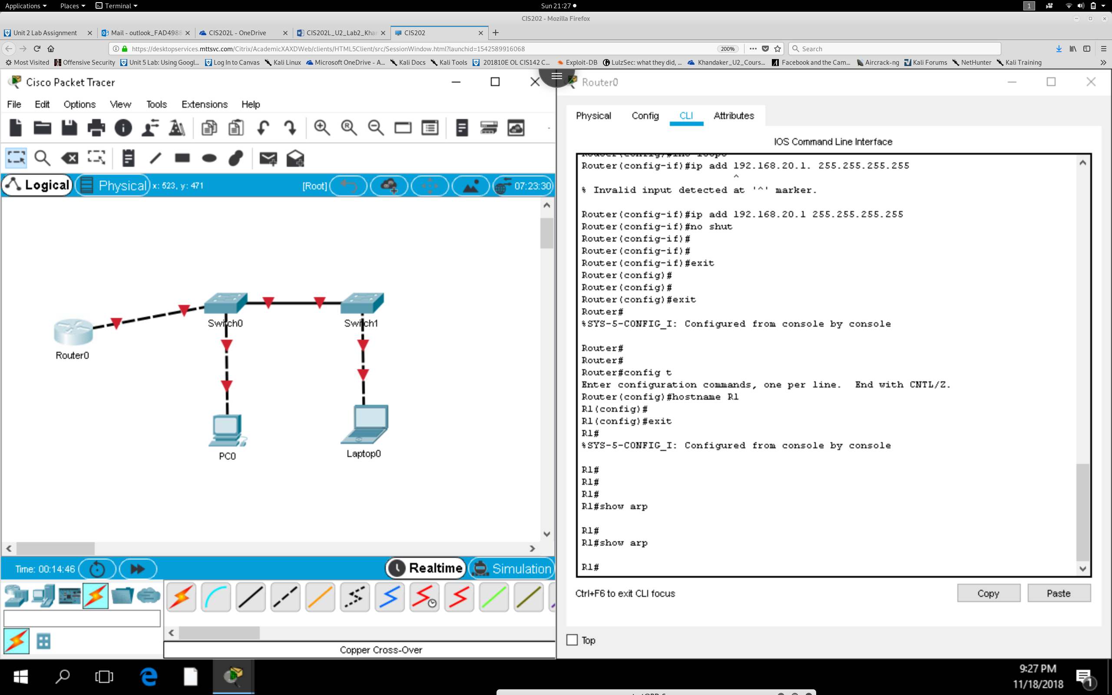

**R1#show arp What do you see as output from Show arp?**

*Show arp shows no output cache of any nearby mac-address in the local connection.*

**From R1, Ping Sw1 address 192.168.10.253. Do Show arp again. How did the output change?**

*Still Does not Show up in the arp cache*

**From Sw1, issue the command Show arp. Compare this output with that of R1. What do you**

**observe?**

*No output*

**Can you think of a reason why SW2’s address does not show in the ARP cache from the ‘show**

**arp’ output?**

*This is because the router cannot communicate with the switch. The switch would need to be configured with a host IP address & I think the ethernet interface is in shutdown mode*

***\*\*\* AFTER TROUBLESHOOTING, I FOUND THAT I USED A CROSS OVER CABLE THAT WAS CAUSE \*\****

***From Router***

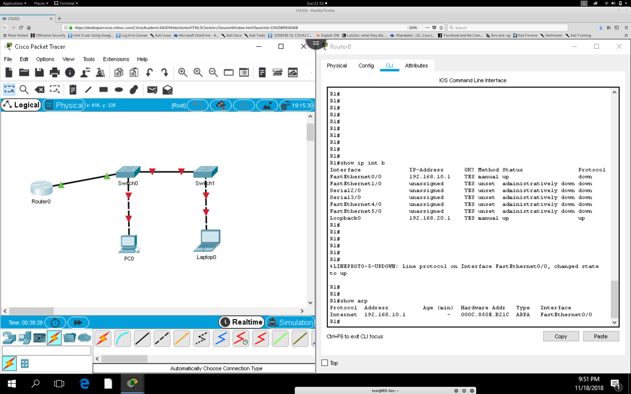

***From Switch***

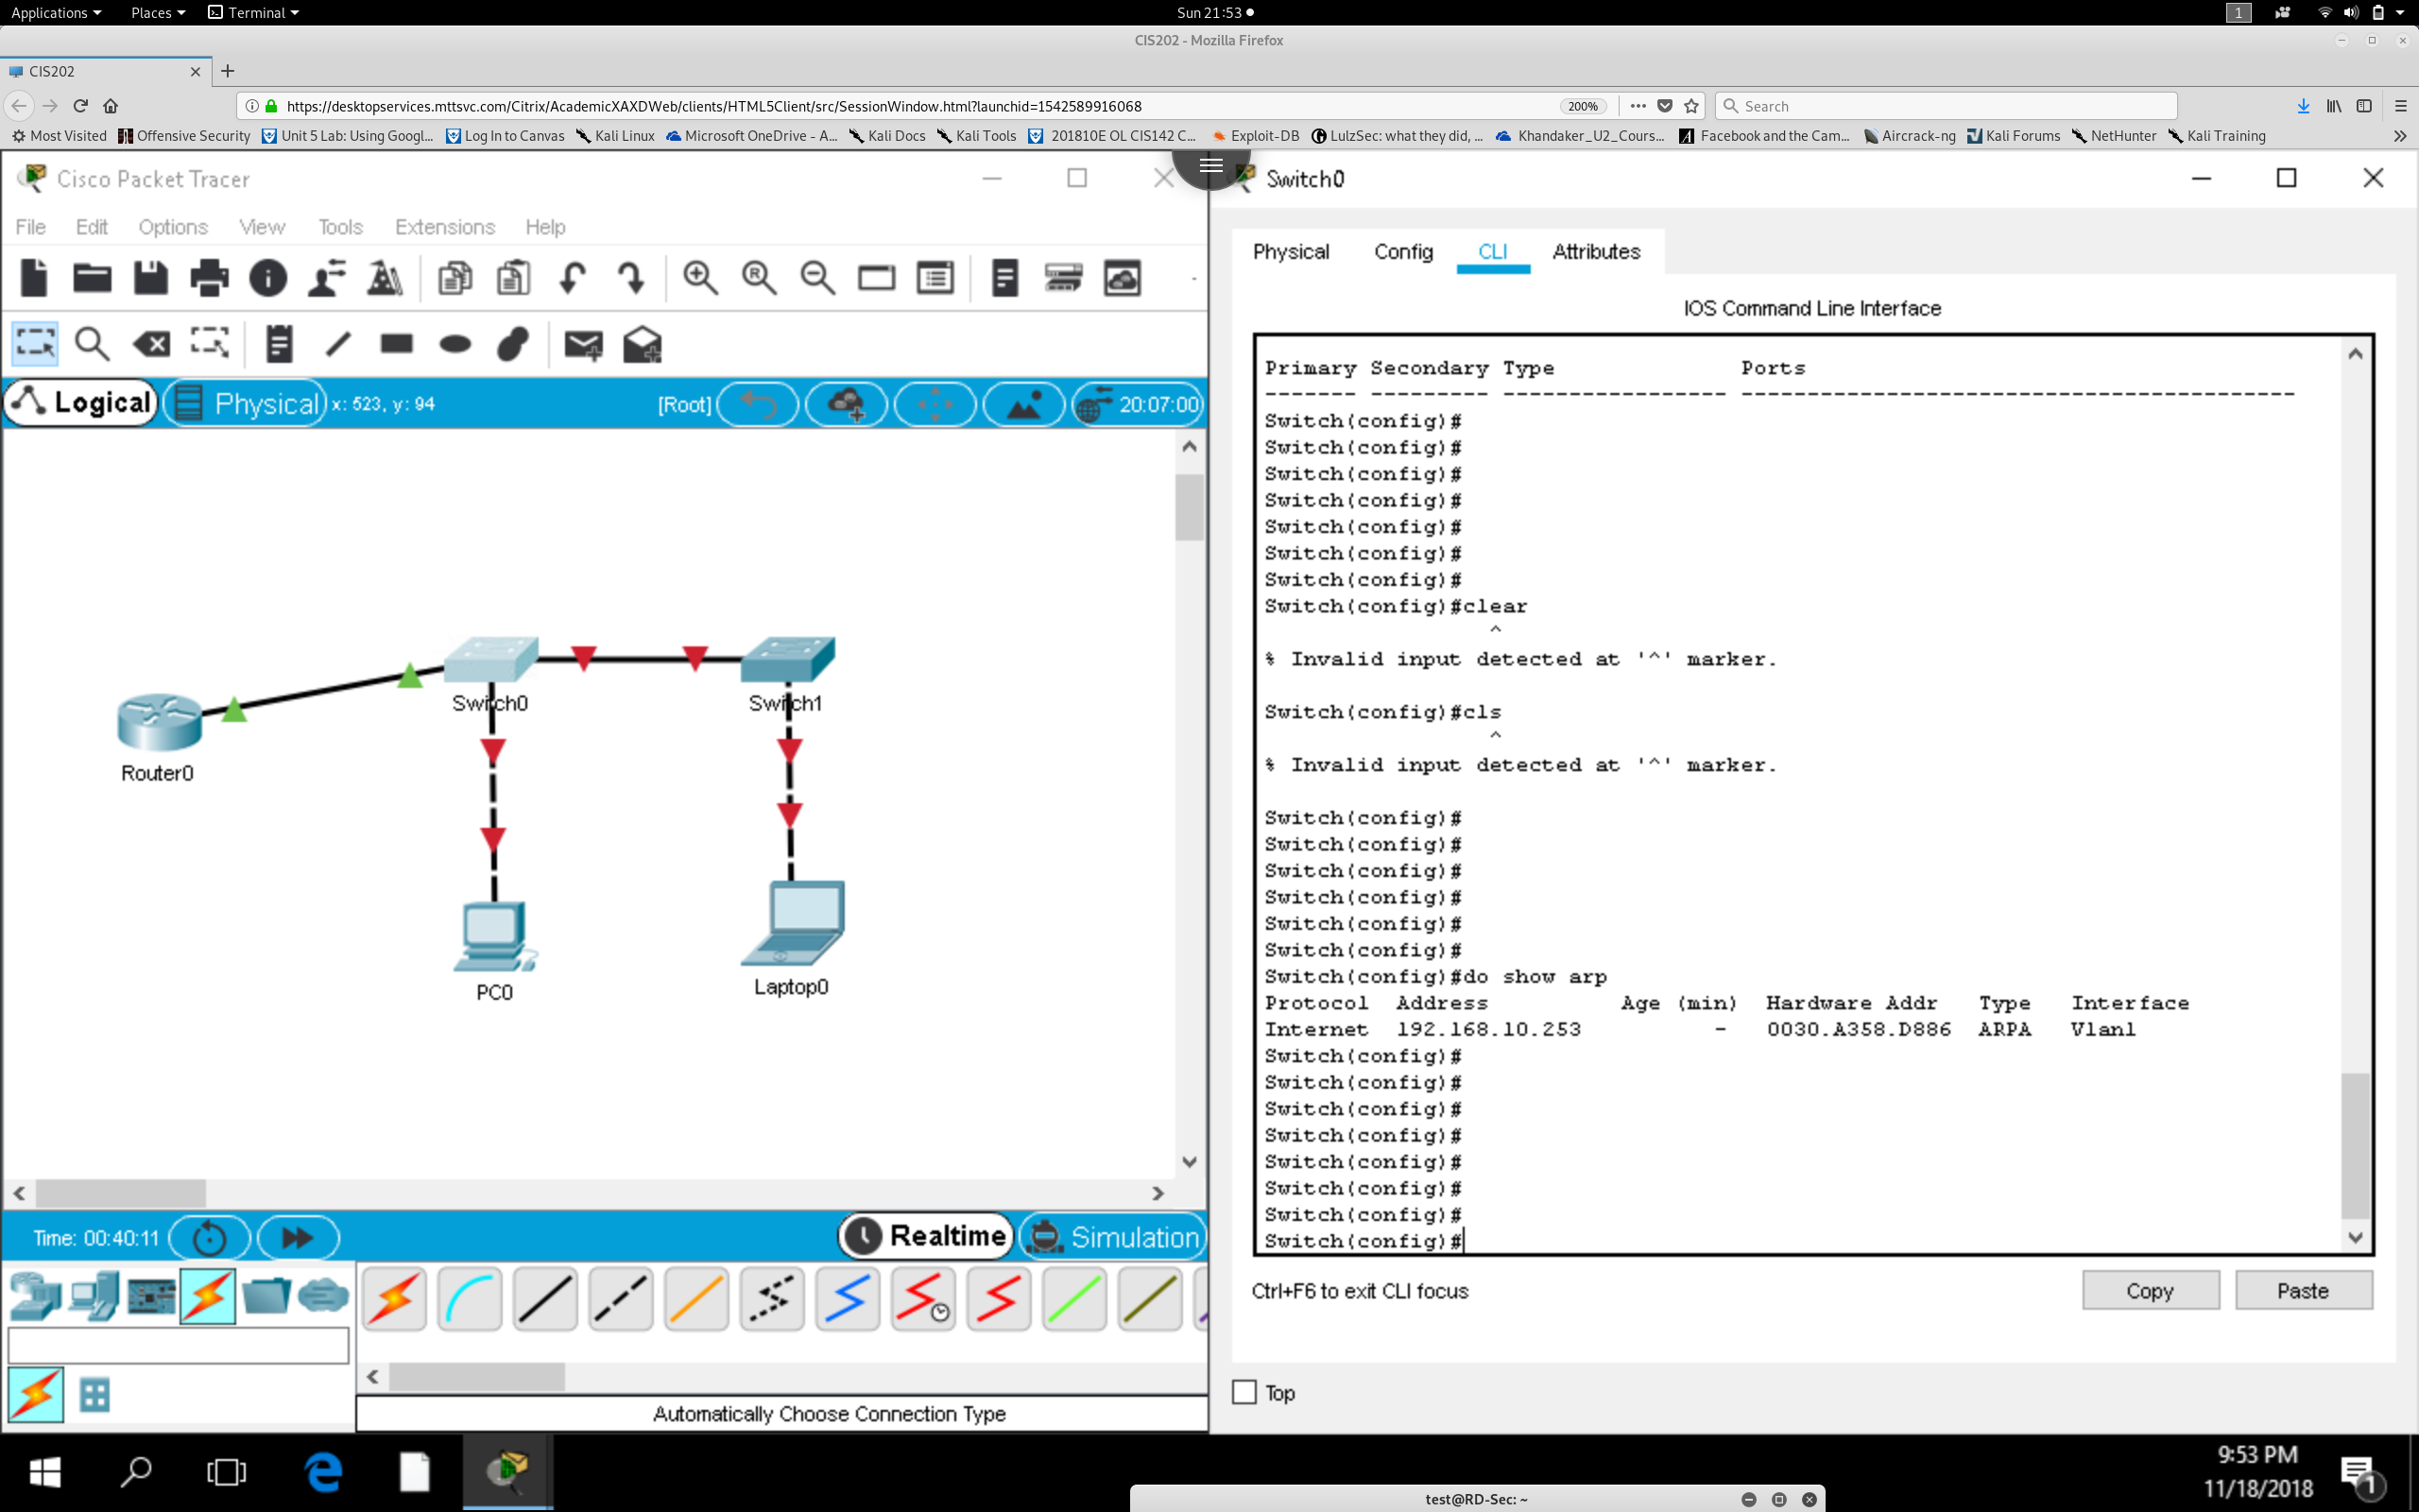

**Step 2:**

**From Sw2, use the command ‘show mac-address-table’ (sh mac-) Examine the output carefully by comparing the MAC address information. Is there any indication that anyone is connected to Sw2?**

*No, there is no indication that anything is connected to this switch. Mac add table is blank. This switch needs to be configured.*

***\*\*\* Configured all devices at this point: \*\****

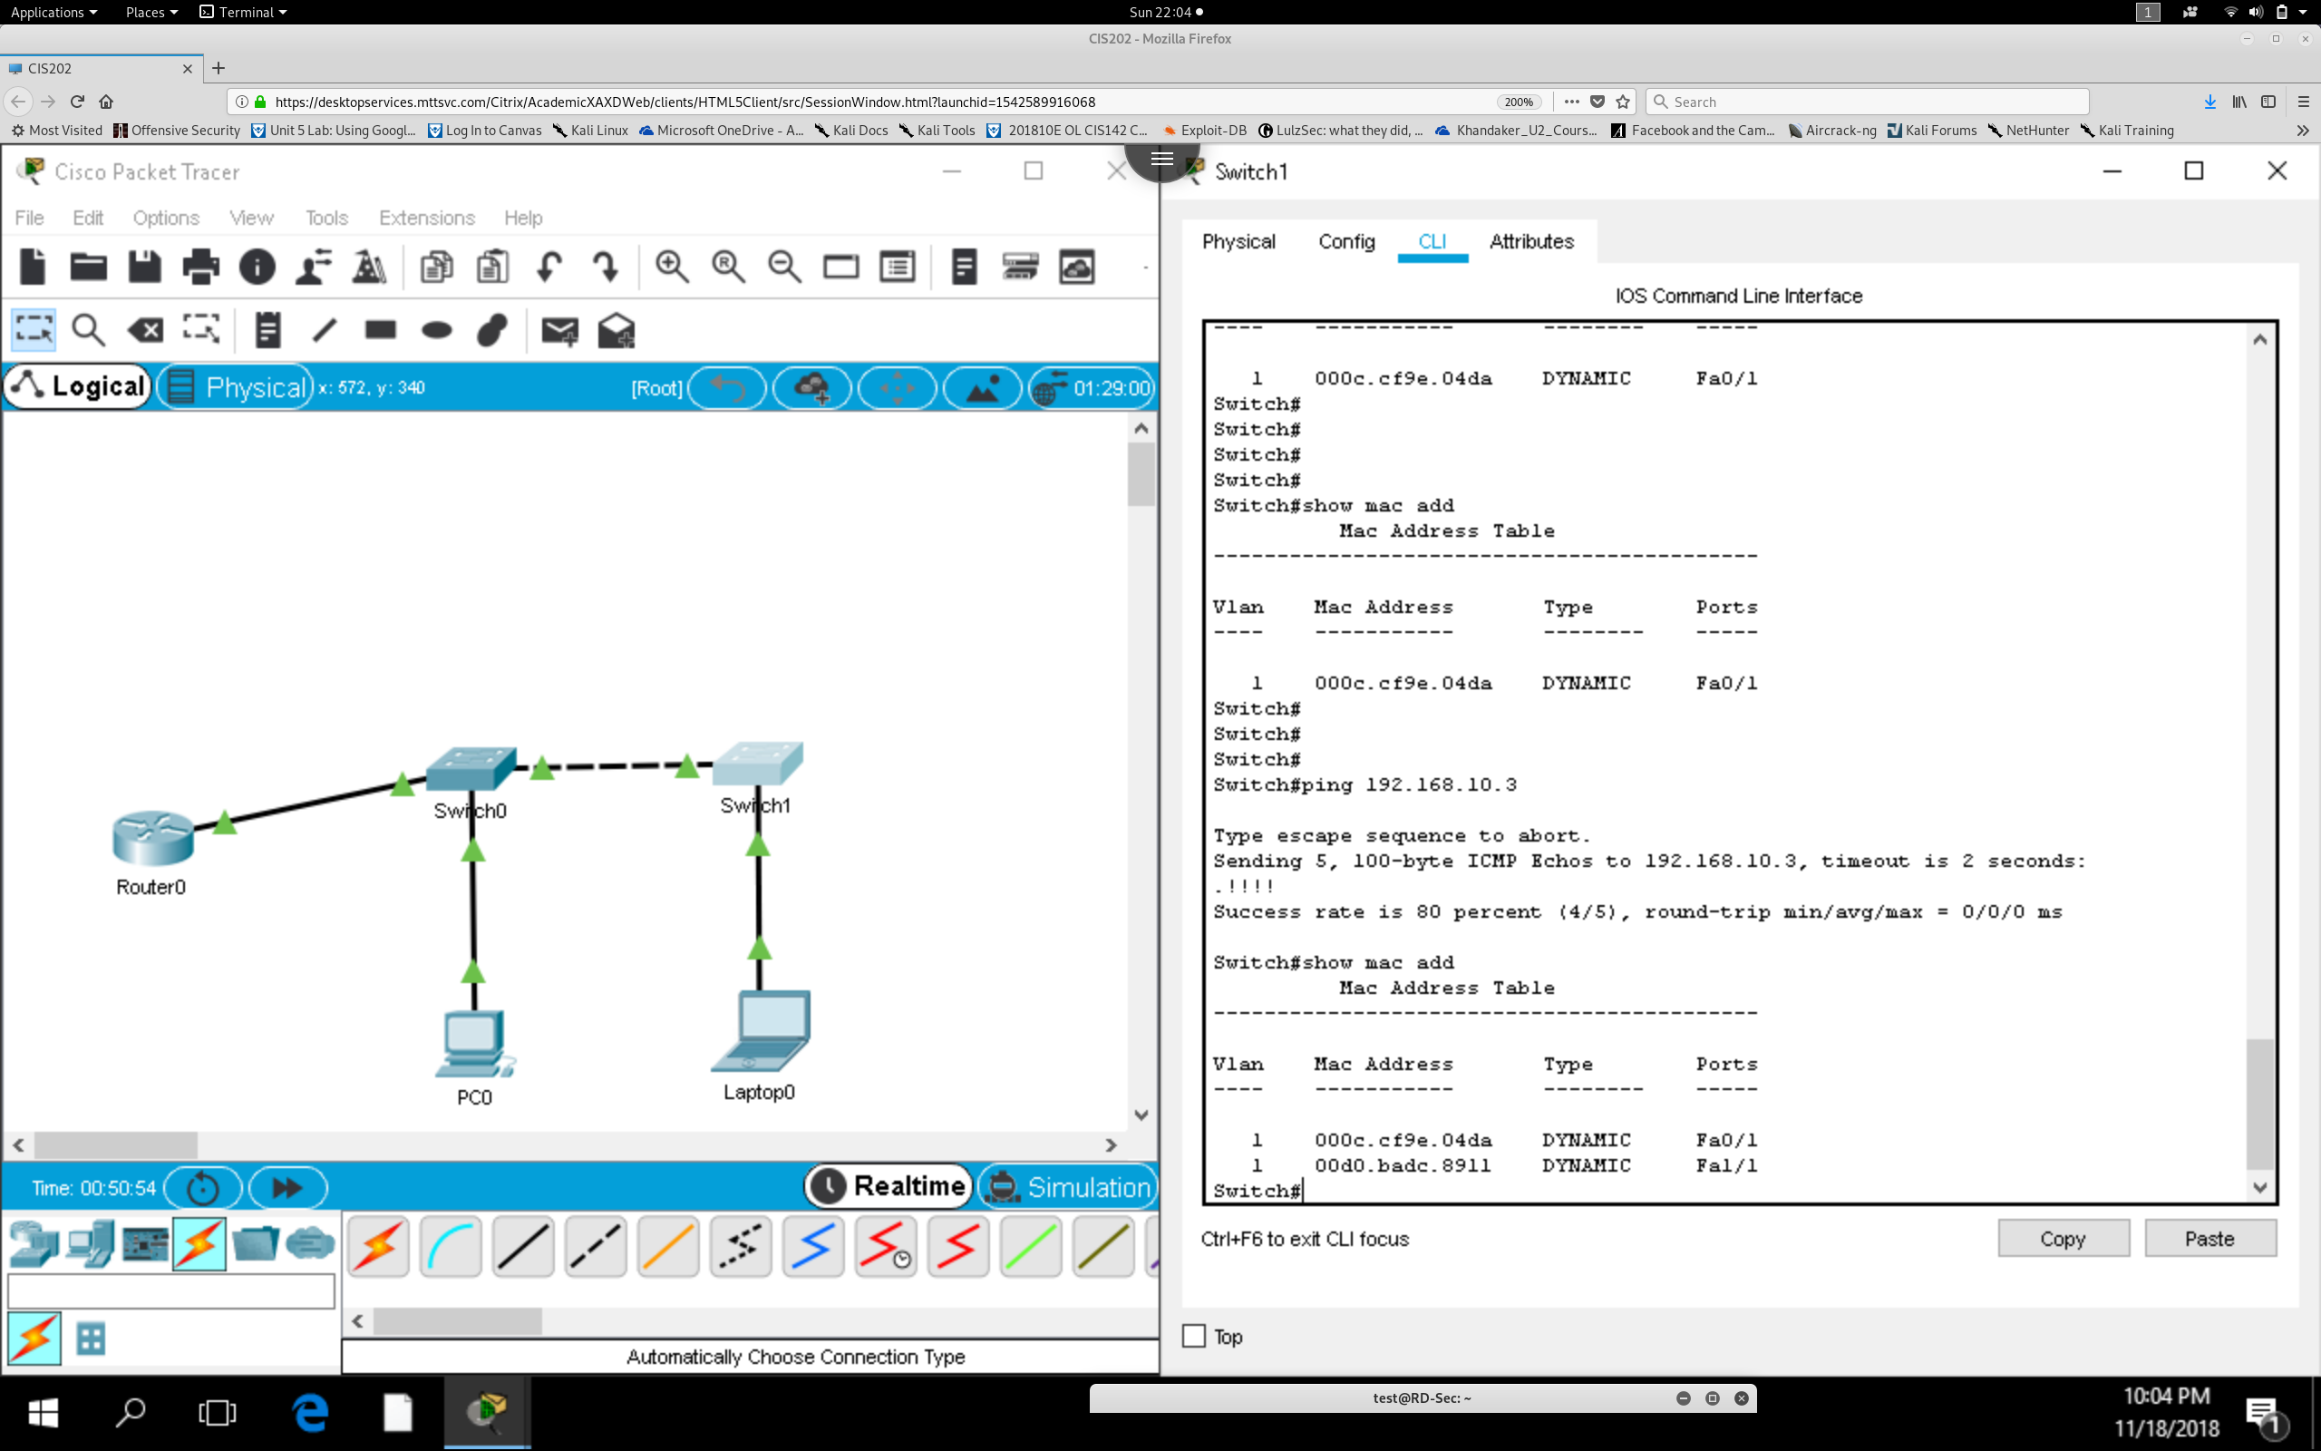

*Mac address is shown that is connected to two devices after pinging the laptop*

***Step 3. Test connectivity between devices and reexamine the table.***

Ping from Sw1 to PC1. Did it work? **YES** (if not, troubleshoot until it works)

Ping from SW1 to PC2. Did it work? **YES**

Ping from SW1 to SW2. Did it work? **YES**

Did you notice an 80% (or less) reply success rate? **YES** Hmm...something to research??

Yes, there is a reason, but your network is working perfectly fine. By the way, try pinging

again. Did it change to 100%? **YES: most likely the first time, the switch sent an arp cache to update its cache before sending the ping request, there for the first ping was dropped because a broadcast was sent to the swtich to find the destination of the default gateway.**

***From Sw1, reissue the command sh mac-address-table followed by the command show arp.***

Compare the two outputs and answer the following:

1**) Are the MAC addresses listed in show mac-address-table identical to those from show**

**Arp?** *Mac address table is built from all the devices connected to the switch. Arp only shows the most recent request made on the network as a temporary arp – cache.*

**2) What Information is added in the ‘show arp’ output, not seen in the MAC Address Table?**

*Arp Cache shows ip information and interface vlan that it falls under. While Mac Table shows the hardware address of the connected devices.*

**Step 4. Caching time examination.**

If you already took a couple of minutes to write the answers in the two questions above,

proceed. If not, wait two minutes to do the following:

Issue the show mac-address-table command again.

What changed? ***We see an entry dropped from the mac table***

What does this tell you about what may happen if the router were to try to send a packet to

***the switch to either PC1 or PC2? The switch will have to build its mac address table to find the destination of the next hardware address, using broadcasting.***

**Step 5. Effects of ping and use of routing through the default gateway on the arp cache.**

Ping from PC1 to 192.168.20.1 (the loopback address) ***PING PASS!***

On PC-2, issue the arp –a command. Note the result.On R1, issue the command show arp. Is PC1’s IP and MAC recorded? **No Record found!**

On Sw2, ping the PC1 address 192.168.10.3 ***PING PASS!***

On Sw2, issue the command show arp. What do you observe about the difference in result on the Switch? (ie, what effects does ping have on show arp and show mac-address-table?)

***Show arp shows the most recent request captured on the network through broadcast request to build the devices arp-cache. We see the request made to ping 192.168.10.3***

This concludes this lab. The main points you should have observed:

The presence of IP Addresses makes the use of ARP possible. Without them, MAC addresses

do not have anything to resolve to.

The ARP cache has a time limit. Without some network activity, it will be deleted.

The MAC Address Table needs network activity to maintain itself.

If the switch does not see a device in the MAC Address Table, it will broadcast to find it, and

then reenter the device MAC Address into the table. This is also why the first ping results in

an 80% success rate and subsequent pings to the same device are 100% reachable.

**Lab 2.4 Exploring Spanning Tree Protocol and Root Bridge Configuration**

**Objective**: The student will observe the effect of Spanning Tree forwarding decisions as it relates to the choice and configuration of a switch as root bridge.

**Equipment**: Requires 3 switches and 2 PCs with associated cables. The VCASTLE pod for this course has

three switches within the topology as seen below. Alternatively, this can be done in Packet Tracer,

however, use of live equipment is recommended. This can be done as a small group project if needed.

Activities to be done

• Topology and Physical setup

• Documenting the ports using the MAC-Address-Table and ARP

• Identifying the Root Bridge

• Configuring a root bridge and secondary Root Bridge

• Observing the effect of losing the root port link to the Primary root bridge

**Background**

Switches are often connected to each other using redundant links. This is called a switch fabric.

In the topology of this lab, three switches are redundantly connected to each other. This also means

that if one link goes bad, the connected hosts will still be able to reach each other. While redundancy is

a good feature to add to a network, it can also create data traffic loops. Routers and switches can both

experience these traffic loops. In the case of switches, such loops can cause data frames to keep moving

around the redundant connections infinitely. This saturates the link and uses up the bandwidth. The

purpose of Spanning Tree Protocol (STP) is to find a single best path from host to host and shut down

any alternative paths unless and until they might be needed.

In this lab, you will examine the use of Spanning Tree Protocol to identify which switch will be

the one through which all the traffic will pass. This switch is known as the root switch, also called the

root bridge in pre 21 st century times. You will also learn how to manipulate the root switch assignment

to change the traffic pattern.

The importance of this concept comes into play because, in large enterprise networks, you may

have hundreds of switches, but a small number of routers. Therefore, understanding how the data

traffic is expected to behave versus how it is actually behaving can often provide clues to any

performance issues. Being able to solve switching problems can be somewhat challenging, but is

fundamental to solving network issues generally.Part 1 Topology and Physical Setup

Confirm that your topology has Switch 0, Switch 2 and Switch 3 connected. Although the VCASTLE

topology is depicted here, the only devices you will require for this activity are the switches.

**Part 2:** Verifying the Switch fabric

**Step 1:** Go to each switch and issue the following command:

Switch#show spanning-tree

Your output will include something similar to the following graphics:When examining this output, do you observe any MAC address differences? ***The root ID mac address is the same while the Bridge ID mac address points to different switch.***

Which Switch has output suggesting that it is the ‘Root’ switch or bridge?

***The switch Highlights on Root ID that “This bridge is the root !” message (Switch 2). Also the Root ID and Bridge ID match on this switch !***

Notice that when the bridge id and the Root id match, that means this machine is the root switch? ***YES !***

**Step 2:** Go to each switch and issue the following command

Switch#show spanning-tree summary

Observe the output at the bottom. You should see a table with the name VLAN001, followed by a list of

the number of ports that are blocked, listening, learning, forwarding, or STP Active.

Does one of the switches have a blocked port? **Yes !**

Which switch is it? **Switch 1**

At this point you should have observed the following:

One of the switches is a root switch

One of the switches has a blocked port

The final switch has no blocked ports, but is not the root switch.

**Step 3. Bring up the Packet Tracer activity that corresponds to this lab and change to Simulation Mode.**

(right side bottom behind ‘Realtime’)

Click on the laptop 0. Then click on PC0.

Select ‘Auto capture play’Observe the route the envelope (frame) takes to move across the switch fabric. Which port did it avoid

even though it seemed like the fastest path? ***It avoided the blocked pport on switch 1***

**Part 3:** Changing the Root Switch

**Step 1**. Access the command line for Switch 1. (note, if your lab had Switch 1 as the root

switch, then choose a different switch.

**Step 2.** Use the following command on the switch.

Switch(config)#spanning tree vlan 1 root primary

Reissue the command ‘show spanning-tree’.

Notice that the two MAC addresses now match, indicating that this switch(bridge) is now the

root switch.

**Reflection:**

Consider what you have just learned. You just changed the root switch from Switch 2 to Switch 1.

Although this was a helpful exercise to show how to do it, the more important question is,

“Which switch should be the root?” **The fastest switch , with the lowest cost should be the Root swtich.**

To answer that question is to suggest some more questions such as:

Where is most of the traffic flow for this network? Is it mostly within the network or will it be flowing

outward through the default gateway? It would not make sense to make Switch1 the root if the traffic is

outward bound and Switch2 is the path to the default gateway. **It makes sense to make switch 2 the root switch because it seems that most of the traffic within the spanning tree network will head towards router ECPI-A and flow out of the local network.**

Which switch has the best cpu/ram and fastest interfaces? It would not make sense to have a gigabit

interface blocked when the network needs to be taking advantage of its robust bandwidth potential.

This concludes this lab. Don’t forget to gather documentation to submit to prove your completion of

the lab based on the chosen platform for performing it.

**Switch 2 has Gigabyte ethernet ports that can support higher bandwidth, also making it a faster switch in the spanning tree network**